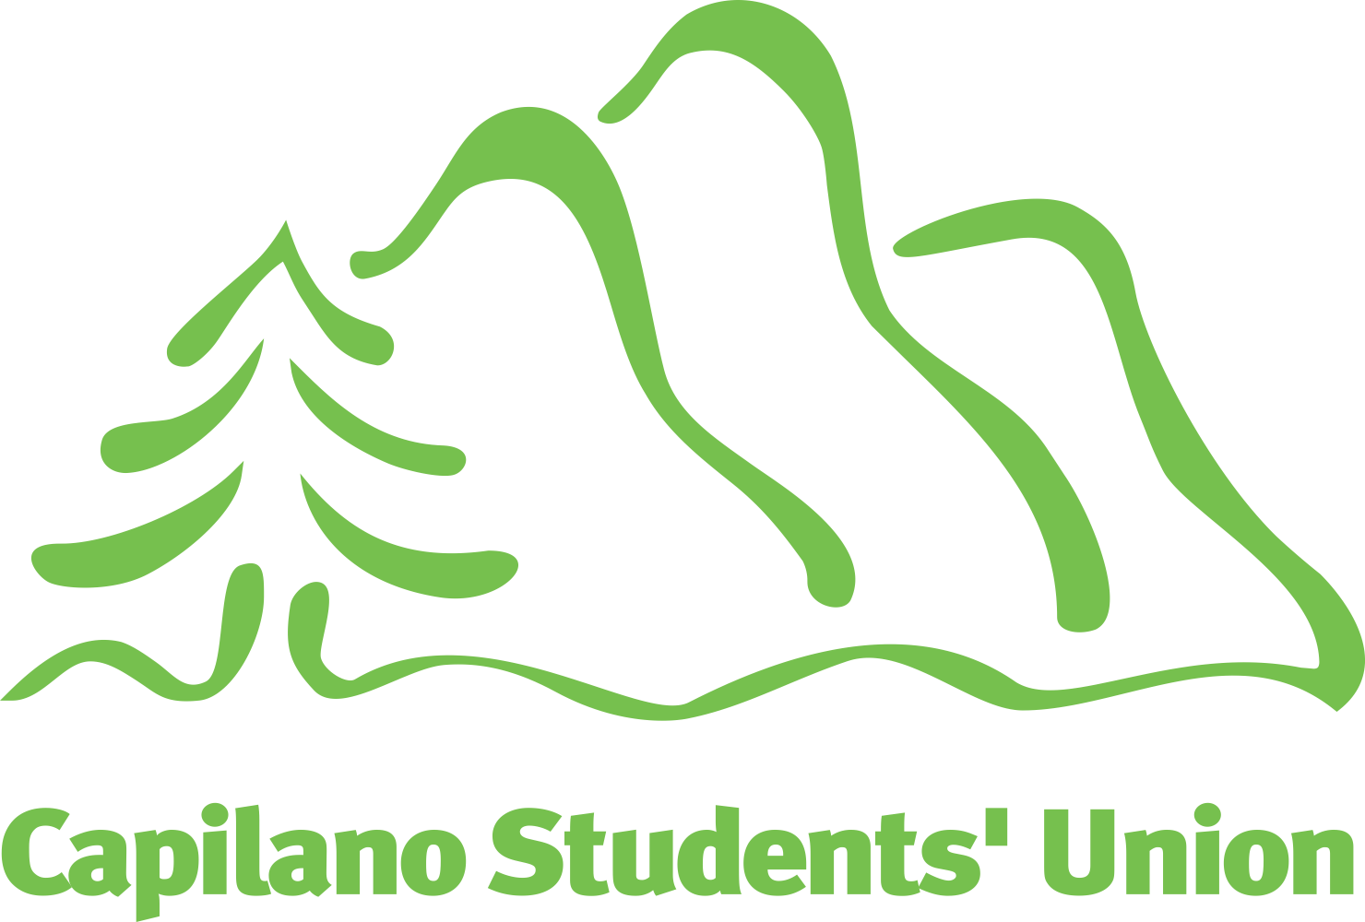
Capilano Students’ Union

Presented at the Annual General Meeting (October 21, 2021)
Report of the Board

Members of the Capilano Students’ Union,
Welcome to the 2021 annual general meeting!
We’re super excited to welcome you back to campus this term (and what a term it has been) as we find new ways of engaging with you both in-person and online. Hopefully health restrictions keep easing, and more opportunities will appear for us to connect!
This is the first hybrid annual general meeting we’ve ever held, with members joining us both in the Maple Lounge on the main campus, and virtually. For us this is a super production broadway style, a lot of effort and planning was put into it, so we hope all goes well and you enjoy.
We know that this is a time of anxiety and of new and unexpected challenges as we all adjust to a new balance of in-person and online learning. Remember that the CSU is here to advocate for the interests and concerns of students, so if you need we are here for you. We've also continued constant dialogue with the administration to ensure students’ concerns are heard and addressed.
The CSU is here to support you. Many of our programs and services are now available both in-person and online, making support from the students’ union more accessible than ever before to students from all campuses and locations. And as all we do is for the students, you can always count on us to at least point you in the right direction.
We can’t do what we do without your input and involvement. The CSU exists to help students and advocate for your issues. We would love to hear from you, and there are plenty of ways to do it. You can book an appointment with the executive team (me, for example!) or visit our friendly staff at our member services desk in the Library building.
There are plenty of ways to get involved, too — you can volunteer with us, join a committee, or even consider running to be a member of our board of directors next semester when nominations open for the 2022–2023 term. The CSU is made for you and by you! We are here together and it’s amazing to have you with us!
Maia Lomelino
President
The work of the Capilano Students’ Union would not be possible without the people who make up our team. As a student association, the Capilano Students’ Union is led by a board of passionate student leaders who provide leadership, oversight, and who determine the direction of the organization; they’re supported by a team of professionals who carry out the board’s decisions and policies.

Board
Maia Lomelino President
Jade Chandra Acting, Vice-President Equity & Sustainability
Aryanna Chartrand Vice-President External
Akira Yamagishi Vice-President Finance & Services
Zabir Montazar Vice-President Student Affairs
Feven Kidane Black Students Liaison
Nandini Sharda International Students Liaison
Mayumi Izumi Mature & Parent Students Liaison
Juliette Purkiss Queer Students Liaison
Brigid Mychael Kálax-ay, Sunshine Coast Campus Representative
Clara Duwel Arts & Sciences Representative
Terrence Alanis Business & Professional Studies Representative
Khwaish Kochhar Senate (Capilano University)
Anmol Singh Senate (Capilano University)

Staff
Oreoluwa Abikoye Resource Coordinator, Black Student Supports
Israa Al-Sakab Frontline Operations Assistant
Asive Cebani Director, Student Associations
Donna Cole Director, Indigenous Initiatives
Jessica De Gaust Executive Assistant
Allan de Jesus Director, Technical Services
Saulo Ferreira Financial Controller (on leave)
Christopher Girodat Executive Director
Kate Jarman Director, Policy & Campaigns
Prabhnoor Kaur Office Coordinator
Lori Kosciuw Director, Advocacy
Craig Levido Director, Student Spaces
Ann Luo Director, Programs
John Morrison Director, Communications
Vy Nguyen Member Services Assistant
Erik Nieweler Research Assistant
Valerie Pham Communications Assistant
Zofia Rodriguez Recreation & Wellness Coordinator
Joshua Thomas Director, Policy & Campaigns (on leave)

Introduction
The Capilano Students’ Union advocates to the university, all levels of government, and other agencies (such as TransLink and BC Transit) to improve learning and living conditions for students. This work happens through action and awareness campaigns, and also through direct advocacy with university and government decision-makers.

Affordability Campaigns

Make the Switch
The Capilano Students’ Union continues to push instructors to “Make the Switch” to open educational resources, to ensure that students spend less on expensive textbooks.
When we last reported to you, we informed you that students had saved over $225,000 so far by instructors making the switch to open educational resources, and those savings continue to grow.
In 2021 alone, students have saved over $300,000!
We want to thank the students that came forward and nominated their instructors during the campaign! Through your submissions, 32 new faculty members were nominated, and we are seeing this number continue to grow.

Student Renters
The Capilano Students’ Union is lobbying the government to extend the rent freeze to ensure that students are not priced out of market rentals. We are bringing your voice to Victoria to ensure that the province understands that it has been hard to make ends meet during the public health emergency, and now is not the time to increase rent.

Awareness Campaigns

Mental Health Awareness
October is Mental Health Awareness month. As part of promoting awareness, the Capilano Students’ Union is working to help end the stigma around seeking mental health support by promoting the new service EmpowerMe.
After spending over an entire year remote learning for most students, there is likely an additional need for mental health support. Therefore, for the 2021-2022 academic year, Capilano University and the CSU have partnered to present all current Capilano University students with access to Empower Me, a student assistance program that is free of cost for a student to access, provides unlimited access to a student in need, and is available in multiple languages, cultural preferences, and for a wide variety of topics.

Get Out the Vote
The Get Out the Vote campaign was a quick fall semester non-partisan campaign that ran to help spread the word on the federal election that was called for September 20, 2021. The Capilano Students’ Union focused on student-specific needs within each party platform and worked to ensure students knew when, where, and how they could cast their votes. The campaign had a few components to it that included in-person tabling in the Birch cafeteria, a panel discussion on the importance of voting with members of the Capilano University community sharing information, and Coffee with Commuters, where we provided coffee and tea and voting information.

I ❤ Consent
The Capilano Students’ Union and Capilano University have partnered to develop the “I ❤ Consent” campaign to educate members of the university community on how to practice and promote consent, challenge rape culture, and support survivors. The campaign will invite many educational opportunities throughout the year.

Relations with Government
Every year the Capilano Students’ Union meets with federal, provincial, and local policy-makers to ensure that the interests of Capilano University students are front-and-centre when making decisions affecting post-secondary educational policy.

Provincial
The Capilano Students’ Union meets regularly with provincial officials to influence post-secondary educational policy and other provincial issues affecting students. Much of our work on the provincial stage is undertaken in partnership with the Alliance of British Columbia Students, our provincial student advocacy group.
Affordable Housing: The Capilano Students’ Union has continued to advocate for affordable housing for students with the provincial government. In recent weeks the Capilano Students’ Union has openly opposed the proposed 1.5% rent increase set to take effect in 2022. With students still reeling from the pandemic and slowly beginning the recovery process along with the rest of the province, a financial hit such as a rent increase could be detrimental to some. The Capilano Student’s Union will continue to encourage the province to make students a priority in the affordable housing conversation.
Family-friendly Units: The Capilano Students’ Union will begin working on encouraging the province to take into consideration the financial needs of post-secondary institutions when student housing is being designed and constructed. As more individuals return to upgrade credentials or start again, often they have families in tow. The Capilano Student’s Union would like to encourage increased funding to post-secondary institutions to allow for student housing to be designed inclusive of family-friendly units. Creating this option can open doors for students who may see the cost of education versus housing as a barrier.
Transit: The Capilano Students’ Union has continued encouraging the provincial government to work with Translink and local governments to improve livability in the region, including improvements to Phibbs exchange and transit corridors throughout the lower mainland.

Federal
While universities themselves fall within provincial jurisdiction, there are a number of issues that interface with students’ interests that are within the jurisdiction of the federal government, and so the Capilano Students’ Union meets regularly with federal officials on student issues. A lot of our federal advocacy work is done in concert with our colleagues at the Canadian Alliance of Student Associations.

Local
The Capilano Students’ Union meets with local mayors and councillors to ensure that students’ needs are being considered at the municipal level. These discussions include public transit, and feedback on the development of student housing projects.
Transit: The Capilano Students’ Union will be focusing on encouraging local governments to work with Translink to increase the region’s livability while encouraging more transit usage and increasing or adding rapid transit to the Second Narrows Bridge and the North Shore.

Transit Authorities
The Capilano Students’ Union meets regularly with officials from TransLink, and with our colleagues from other student societies and post-secondary institutions in the region, to ensure that students have access to adequate and affordable public transit services.
U-Pass BC Program: Since the pandemic started, students continued to pay u-pass fees while the service was not fully operational. As a support, the Capilano Students’ Union helped to provide those students that needed the financial lift access to a support fund that granted up to 50% of the cost of the u-pass fee back to students. In addition, the Capilano Students’ Union will continue to collect data from the student ridership and work to add more buses, shorten wait times, and continue to advocate for improvements to Phibbs Exchange.

Relations with Capilano University

Senior Administration
The Capilano Students’ Union meets regularly with the university administration to advocate for students. Our discussions continue to be centred on the concerns of students during the university’s management of remote service delivery and learning.
University executive: Our executive team meets with the entire university executive once per month to discuss student issues. We have used this forum to continue conveying students’ concerns about how they are being supported during the pandemic and, in particular, on the importance of clear and open communication with students, and flexible and compassionate approaches to decisions affecting students.
Gender diversity audit: We have been hard at work to improve access to the university’s support services for trans, Two Spirit, and gender non-binary students following a 2018 joint audit of the university’s policies and practices. Expect more from us this semester, with programming targeted education for cisgender community members on how we can create safer spaces for our trans, Two-Spirit, and non-binary peers.
Family-friendly units: The Capilano Students' Union is encouraging the university and administration to work to include family-friendly housing units in future housing developments on campus, as the “traditional” student image shifts to be more inclusive of parent students and their needs.

Board of Governors
The university board of governors is the senior governing body for the business of Capilano University. Select executives and staff of the Capilano Students’ Union attend meetings of the board to stay informed on critical decisions that might affect students. Student members of the board of governors are also invited to serve on the Capilano Students’ Union board of directors in an ex officio capacity.
Tuition and Fees: The Capilano Students’ Union is encouraging the university administration and the board of governors to adopt more equitable tuition and fee practices between domestic and international students, and to ensure flexible approaches to things like fee payment deadlines, fee deferral rules, emergency financial assistance, and refunds and tuition waivers — especially in this pandemic context.
Equity, Diversity, and Inclusion: The Capilano Students’ Union in partnership with the Capilano Faculty Association, and MoveUP to encourage the Capilano University Board of Governors to oversee an Equity, Diversity, and Inclusion audit of the university and seek for improvements across all areas of the university.

Senate & Academic Issues
The university senate is the senior academic governing body of Capilano University, setting curriculum, grading profiles, and other academic matters. The four student senators also serve on the Capilano Students’ Union board ex officio, and the Capilano Students’ Union also sends a permanent guest to speak at the senate table.
Academic Schedule: The Capilano Students’ Union is currently advocating for the university to extend its one-day fall reading break into a full week-long break, and to extend the period within which students can withdraw without academic penalty. The university is “opening up” the academic schedule policy to community feedback, and so this is the perfect chance to make students’ views known to the administration.
Extension of the Add/Drop period: The Capilano Students’ Union saw success in encouraging the university to extend the add/drop period to later in the semester, with students now having four more weeks in the Fall and Spring terms within which to make a decision to withdraw from a course with a “W” on their transcript.

Introduction
The Capilano Students’ Union provides a number of services to make students’ post-secondary experience more fun, affordable, and meaningful. This report summarizes the key services that we deliver to support students.

Major Services

Empower Me
Empower Me combines progressive counselling methods and technology to provide an assistance platform that is available 24/7 for students anywhere in North America. It connects students with consultants, counsellors, and life coaches to provide them with appropriate, multilingual support in over 180 languages. Plan members are entitled to sessions delivered in person, by telephone, by video-counselling, or by e-counselling. Support is available for a number of issues, including:
- Academic issues
- Adjustment to post-secondary life
- Anxiety and depression
- Bullying
- Career development
- Crisis
- Discrimination
- Drugs, alcohol, gaming, smoking
The Empower Me services help to fill the void often left by campus resources to offer support after hours, over the weekend, during holidays, and when on-campus services are booked up. With the costs of the service prepaid, you don’t have to pay any additional usage fees!

Health & Dental Plan
Through a partnership with Studentcare, the Capilano Students’ Union continues to provide the student health & dental plan. With information on how to claim on Studentcare’s website, this service continues to be administered entirely online. Additionally, students can reach out regarding any questions about the plan through email, social media messages, or telephone.
This year, to ensure the experience of full-time students is consistent, full-time students starting their school year in January will now also be automatically enrolled and will no longer have to self-enrol. However, part-time students must still self-enrol in their starting semester.

Emergency Financial Assistance
U-Pass BC Hardship Fund: Acknowledging the exceptional circumstances around the resumption of the U-Pass BC program, students who are experiencing financial hardship are able to apply for a bursary from the Capilano Students’ Union through the U-Pass BC Hardship Fund. Applications remain open on the Capilano Students’ Union website.
Internet for Good: Access to technology is more critical than ever for your academic success while learning and accessing support services remotely, which is why the Capilano Students’ Union has partnered with Telus to provide access to the Internet for Good program for Capilano University students. This program offers a basic Internet plan to CapU students experiencing financial hardship for $9.95 per month. To access the program, apply through the Capilano Students’ Union website.

Renters Insurance
The Capilano Students’ Union has a partnership with Apollo to offer students renters insurance designed with students in mind. As a result, students can ensure their personal belongings, protecting them from costs associated with break-ins, fires, floods or more. Learn more about Apollo’s low rates through the Capilano Students’ Union website.

Device Doctor
Device Doctor offers personal electronics repair and technical support for free or just the cost of parts. Not only is this service available in person at the Members Centre (Library 195), you can also access the Device Doctor remotely. For remote hardware repair, devices are shipped back and forth without direct contact between students and staff. Services include:
- diagnostics
- screen replacements
- data recovery
- hardware upgrade installation
- general mobile/tablet/computer repair

CSU Book Market
The CSU Book Market is our online platform to buy & consign your textbooks. This web model allows students to consign and purchase their textbooks throughout the semester. Our contactless online store also makes the service more accessible for remote and kálax-ay students. Not only is this service available online, but you are also able to come & consign your books in person at the CSU Members Centre (Library 195).

Volunteer Program
We are continuing to identify more volunteer opportunities for students during the transition back to campus. Some current positions include being a CSU Ambassador, event volunteer, campaign volunteer, or opportunities within the Capilano Business and Professional Society. To view the complete list of current options, check out our volunteer registry.

Recreation Program
The recreation program has resumed in-person programming in accordance with public health guidelines. Some of our programming highlights in 2021 so far have been: kayaking, dog therapy, and drinks & games night. Stay tuned for upcoming events, including Lazer tag!

Student Spaces
Beginning the week of October 25, both the Maple Lounge (Maple 115) and the Members Centre (Library 195) will be available for space booking. If you are interested in booking space at the CSU, submit your request through the Capilano Students’ Union website.

Clubs & Student Groups
The Capilano Students’ Union’s clubs and student groups are back operating in person! With access to grant funding (including $200 of core funding), event planning, and administrative support, starting a club is a way to build a community. Learn more about creating a club or join an existing group on the clubs’ page on the Capilano Students’ Union website.

Supporting Services

Community Cupboard
Our Community Cupboard program has transitioned back to campus, and we are keeping the online option. This program provides students with financial support to access food before connecting them with community resources. To access our physical community cupboard, please visit our Members Centre (Library 195). To apply for an electronic grocery gift card (of $25), visit the community cupboard page on our website.
The CSU is also a referral partner for Quest Food Exchange. Quest partners with local wholesalers, supermarkets and farmers for a typical shopping experience at a reduced rate, far below retail value.

Community Closet
Community Closet has officially soft-launched in the Maple Lounge (temporary home), with the move down to its permanent home in the Members Centre (LB195) as the lounge opens back up. Students can come to partake in this free clothing exchange to promote additional financial support to students as well as be a sustainability-focused service. Keep an eye on this service to see some exciting upcoming expansions!

Locker Rentals
As we have transitioned back to campus, our locker rental service is available for students to use. You can rent your locker either in person at the Members Centre or online via the CSU Book Market.

University Appeals
We continue to provide full support for student appeals & advocacy through online delivery. Our staff are available via email, telephone and video meetings to advise students on navigating appeals and the university process. We also have some helpful tips for self-advocacy on our website!

Community-building

Welcome Back
We're delighted to be able to start delivering in-person programming and special events again this year. On September 23, we held a lower-key version of our annual Welcome Back get-together, adapted with safety measures to keep students safe and to meet the province's public health requirements. We've already started to reintroduce regular social events in our student lounges, too — we hope to see you soon!

Catalyst
Our second annual conference on equity at Capilano University is just around the corner! Join us on November 2, 3, and 4 to hear students share their experiences navigating discriminatory post-secondary spaces, to discuss how to support and lift up Black community-building and organizing, and to experience activism through art.

